**PRO 5.2. Junit II**

**1. Métodos Test**

**assertEquals()**

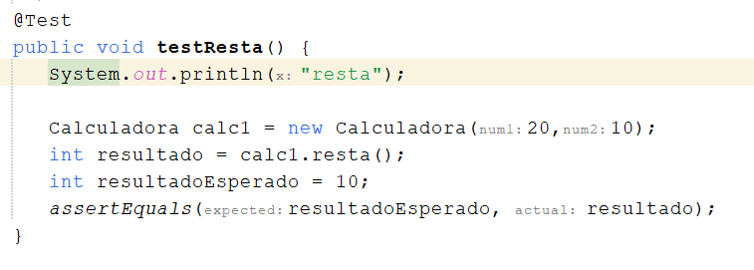

**assertTrue()**

**assertNull()**

**Resultado de los Tests**

Para usar **assertNotNull**() y **assertFalse**() los códigos serían:

**2 - Fecha**

Pruebas para probar la clase Fecha:

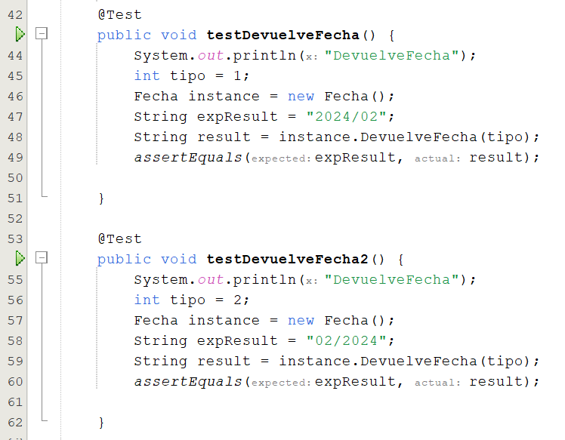

Resultado de las pruebas:

**3 - Factorial**

Pruebas para probar la clase:

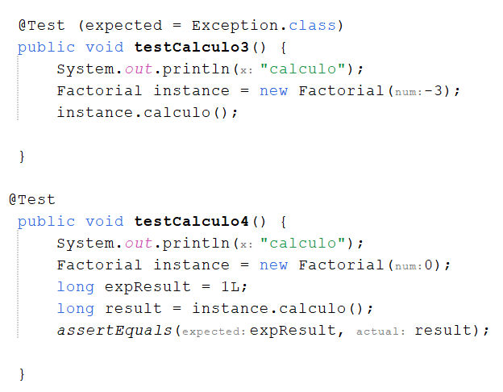

Resultado de los tests:

